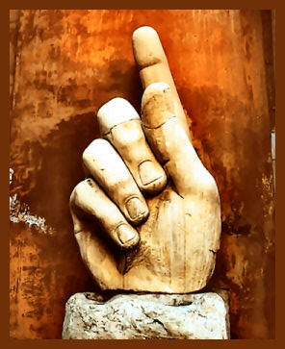
Right Hand Pointing
Sees Small Sky
Issue 11
cover photo by Mary Ann Sullivan
http://www.bluffton.edu/~sullivanm/
Copyright 2006 by the authors and artists of this issue.
No part of this book may be reproduced or transmitted in any form or by any means without permission by the author.
All rights reserved. All poems, fiction, articles, essays, and artwork are the property of the authors and artists within, and as such, are protected by applicable U.S. and international copyright law.Copying or reprinting in any form is prohibited without permission of the author or artist.
Editor's Note

11
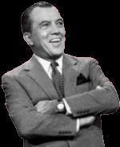
In this issue, there's a poem by Joanne Lowery about the Ed Sullivan show and it reminds me of a memory of watching the Ed Sullivan show when I was a kid. One Sunday night, Ed had a magician on. Ed had lots of magicians on, usually flashy and usually working with a girl or two, unlike Ed. This magician looked like an accountant. Short-sleeved white shirt and a tie. Very little in the way of charisma. He did card tricks. Specifically, he made cards disappear before our eyes. Here's my recollection: The camera gave us a tight shot of his hand. He'd put a card in the hand. He put the hand out so the camera could clearly see the card in his hand. He wouldn't move his hand and the card would disappear. The card wouldn't just disappear, it would fade out. The card would be there. We'd see it start to fade and see the guy's hand fade in behind the card. And it would be gone.

Ed had reassured us there were no camera tricks. (There is no proof that Ed Sullivan ever told a single lie in his life.) This had to be no later than 1965 or 1966. If there had been camera tricks, I'm not sure exactly how they would have pulled if off.

Here's my simulation, except this simulation involves a card with Don Rumsfeld disappearing.
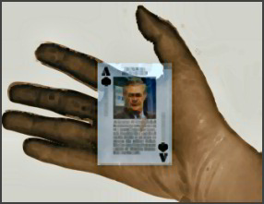

The tricks were all pretty much the same. Look at the card. The card is here. Now it's going away. Now it's gone. The tricks were both amazing and sort of boring. This magician, flat of affect, absent much in the way of flourish. No misdirection. No smiling girls with skimpy costumes and broad, distracting gestures. Just this guy, making playing cards vanish into thin air. The crowd applauded a little, and then the applause died down. I think they might have been a bit bewildered. I never saw this magician again.

What if there really was an ordinary, boring guy with real magic powers? Would he be forced to try to make a living as a magician? What if the tricksters did better on the magic show circuit than he could? What if the guy who really could make cards vanish into thin air had to sit by and enviously watch the showmen upstage him with sleight of hand?

We're pleased to have several first-time contributors to Right Hand this issue. Welcome to Joanne Lowery, Carl R. Brush, Shanna Karella, Antonios Maltezos, Claudia Ryan, Frances Raven, Steven Dines, Chris Major, Eric Burke, Laura LeHew, and Suchoon Mo. And welcome back to recidivists Helen Losse, Cleo Kocol, Manfred Gabriel, and Monte Davis. Special thanks to Carol Skinner for editorial assistance.

Dale
The Editor
Joanne Lowery
The Misters Banjo
are the size of fingers, proportioned like men
running up the Smokies and down Shenandoah’s wide plain,
living their tachycardial lives as fast as they can
plucking and frailing and slurring on strings
until their heads turn paprika and sumac red.

It’s a good life, better than guitar,
faster and fancier than mandolin.
Each of them parses a song into sounds
the way a lake can become raindrops again.
Afterwards: a cold bottle to hold, a fly
to brush away, a woman’s beautiful butt
passing by to imagine repeating rhythm on.
Ten restless guys race to fill her ears or her pants
scrambling to give pleasure.
Joanne Lowery
Ed Sullivan as Muse

A long face, a knot of heavy hands
announces what I am about to do.
Television’s solemnest M.C. convinces
faithful millions to stay tuned for
four shaggy guys from England
and a ventriloquist, my modest song
still in the wings rehearsing
till his voice booms, arm thrown back,
curtain crumpling like another sheet of paper.
This, right now, is my big chance to prove
I can tap-dance sixteen lines back
and forth to entertain and enlighten you.
If he thinks I can, the act will follow.
My heart pounds, he speaks my name.
I’ll be quick, almost perfect.
He’ll make you applaud like it’s Sunday night.
Joanne Lowery
Meteor

Midnight, deck rocking and awash,
the captain tries to estimate the waves
by comparing them to a barn.
Ten feet or twenty? Thirty

slam starboard and up he flies
with miles of white foam behind him.
Joanne Lowery
Racking

The student who's ruined my class
with her whispering, snide remarks,
and head on the desk in boredom
pops like a party favor as four ropes
pull her smirk apart. Now
she has reason to hate me, and now
again as I give the crank another whirl.
Joanne Lowery
Death Sings His Heart Out

after hollowing a portion of scythe handle
to make a larynx
and sheathing his boney ribcage in plastic
for a bellows

and asking a bird to be his tongue:
then it’s just jaw jaw jaw
over and around puffs of air
and all of life’s emotions.

So this is how it feels
to express how it feels
to feel—he is the baritone pied piper
blackening our high notes.
Carl R. Brush
All Souls
Halloween Nicholas, after her newest lover had climaxed but still remained strong inside her, whispered to him the story of her name. She dipped her slight breasts toward the darkness of his face and asked him not to move or interrupt no matter what because if she could tell it all at once her mother, after years of searching, might find her at last. Perhaps this very day.

Halloween told how Father Nicholas had lifted her, a swaddled foundling, one All Saints Eve sixteen years ago from the steps of St. Louis Cathedral in New Orleans then pursued by flashlight a trail of glistening blood spots across the cobblestones, past Andrew Jackson’s statue, beyond the Café Du Monde, across Bienville Street and into the French Quarter where they’d finally disappeared and with them the last trace of her anonymous mother.

Still whispering, she grazed her nipples over his rough cheeks and tightened her hold on his waning tumescence as she described how that birthday morning someone had discovered in St. Louis Cemetery One an oozing placenta on the grave of Marie Laveau the Voodoo Queen. How the media had given her that haunted first name. How the good father by dividing and thus multiplying his monastic eponym like New Testament bread had bestowed on her the beatified Nicholas as a surname before passing her on to the nuns.

So I’m Catholic Voodoo she said isn’t that a trip and told him when he was limp and separate to keep still please while she dressed saying hail Mary and forgive me Father and Marie please lift your curse then walked out the door into San Francisco gloom and headed toward salt-spray rocks where she would huddle waiting for what her heart knew would never come. The sun to rise from the western sea.
Manfred Gabriel
Afternoon

I feel no fear
When noon
Slips into afternoon

I must close my eyes
The sun
Warm on my face

Eyes closed
And life
Slipping into afterlife
Shanna Karella
And See My Body Bend

And see these straight lines, bound
my wavering, as if they could border
liquid and hold it

in by rough will alone. I splinter
into segments; rail against the frame
like a tree with too-tight bark.

And see these hands raised up, to ward
the sunset's burn: my brows and lashes
flame, my scalp flows

crimson. Even when I close
my eyes, afterglow blazes
through tight lids: there is no rest.

And see the passersby a million feet
too late and far away, still clothed
in disregard

of wayward screams, carried on
the gusts, or roiling surf, or falling
through the cracks.

And see my startled face held up,

and see my body bend.

Inspired by "The Scream" by Edvard Munch.
Shanna Karella
And Remake My Bones

I was old at my birth, teeth fallen out,
fetid breath sucking at slack corners.

Pushed a walker as a toddler does that toy
shopping cart, putting in all the colored pains.

My veins were black and bulging at five,
knots and ropes writhed beneath thin skin.

I could bruise by breath alone: barometric
in relief, like friezes on the inside.

The middle age occurred at 4:01 AM
last Saturday, just as I turned twelve.

My eyes no longer tear, my tongue is sere,
as youthful flush eviscerates all moisture.

Menopause marked my adolescence
with congealed blood and petrified egg.

I wait for the viper to worm from my navel;
for morning to break, and remake my bones.

Shanna Karella
Sees Small Sky

her eyes open, like two cupped
hands, water falling from that cleft

to pool in granite basin, percolate
through bowels, feeding caverned seas

salt crust deposits form, dry leaving
mineral marks to scar her face

some lock falls down, keys her
hand to brush, one hundred strokes

door knock, wakes and turns
knob in hand, real metal there

last dream, glance then open
sees small sky, eyes looking up
Antonios Maltezos
Veneer

They had on their knitted hats, the puffy red ones with the pom-poms hanging off the side. They wore their hats tilted, showing off their matching curls. They were so cute walking together in the park, swinging their arms, scattering the leaves with their big steps. Every so often, his wife and daughter would look back at him over their shoulders, giggling because they were so happy.

“I’m still here,” he’d say, wave at them, trade smiles, and then shove the hand back in his pocket.

Kicking the leaves they’d scattered helped ease the walk in the park.

Claudia Ryan
Listening

Stupid, stupid, stupid, stupid, stupid, stupid, stupid, stupid, stupid, stupid, stupid, stupid, stupid.
The opening statement is a blank invocation.
If I stay still I don’t mine over there
Or get taken in by a loose dirt circumference, with fluid marking the spot
Under the down- stairs couple,
Shaken at war, at simple,
And for the rest of the universe sleeping
A blue, white, and grey sleep’s worth,
Then slip out over the rose head alive.
Francis Raven
from "Poems About Reaction"

15.
I wanted to learn about economics,
so I pulled out 10 books from the library
and sat down at one of those cold library desks -
proceeded to read 6 pages
(2 from Sraffa, 4 from Pareto),
went outside
to lay eye level with grasses
and write a poem.
The cost/benefit analysis
followed me slowly
but I didn't run.

17.
The thing is
that days are rain
and the night knows
whether you are a tarp
or the ground
soaking
4.
I always read the last poem,
in a book of poems,
first -
I always expect
it to be the destination
of the whole book -
but somehow
it never works like that.

6.
A spent moon in every receipt -
The memory of the moon on the paper;
The doubt you share is holy,
but the trust is a holier background
for all of your doubts
to rest their hands upon.
Eric Burke
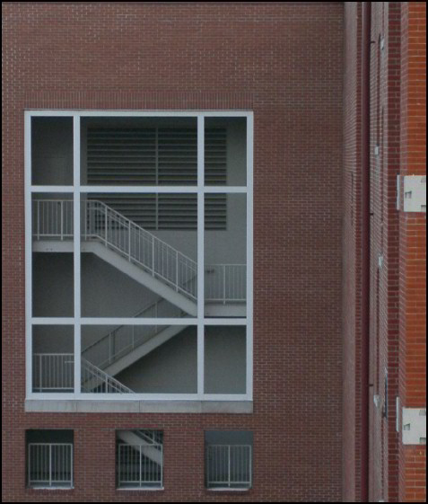
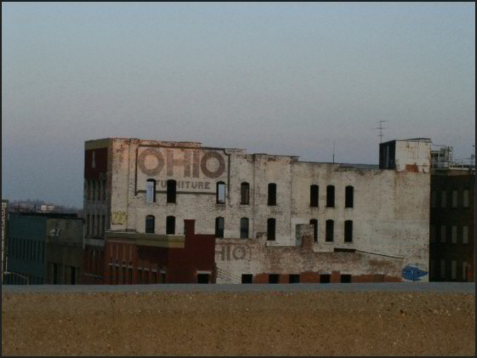
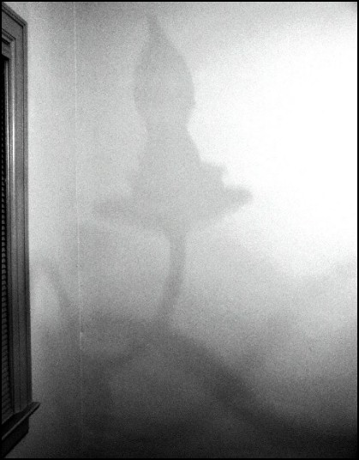

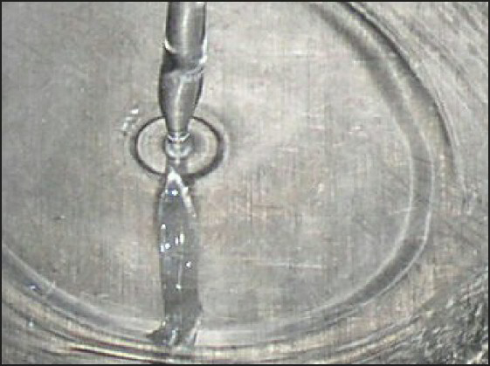
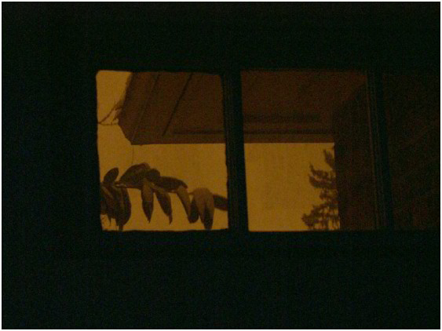
Steven J. Dines
Mash

Dad says there's something wrong with me if I'm fourteen and still messing around with my food. Eat the bloody mash. Quit building stuff with it. But I can't stop myself. Carrots are good, too. The carrots I've regimented on my plate while on the cooker fat spits at the bacon frying in the pan and Father yells at Mother not to cremate it again. Peas I cannot stand: they don't conform to my fork's will, but roll wild around the plate instead. My parents, they love peas. But for me, mash is where it's at. When I lean back to assess my sculpture—a geometric dome cooling to an igloo—I'm reassured by its familiar lines. But the bacon is inevitably blackened, drawing a loud slap, quiet tears, and a "start over until you get it right." If she served it raw straight from the packet—she wouldn't dare, but if she did—he'd insist it was burnt anyway. I wish I could crawl inside my mash-dome, through the entryway I've just scooped out, but Dad's fork descends upon it from nowhere, flattening everything on my plate. Eat it, sonny. Mum just drops
another two rashers into the spluttering pan as I look sadly at the devastation in front of me.

Tonight I'll eat, but tomorrow I'll build it again.
Cleo Kocol
The Blues Man

tosses a riff saying
life is a slipshod serenade pinching
pride, bruising the undertones.

Her velvety voice hums a reality
he doesn’t coax from his sax. Clinging
to resistance, he improvises.

She slows for the melody, punching
lead lines. Negating bitter and mouthing
sweet, she tosses vibrato at him.
The Blues Man

Bluesy contralto. No room for
anything but gut-grabbing emotion.
A throb of longing duels with
music crying his head.
Cleo Kocol
California Capital

Shade-tree Sacramento, casts
shadows of innuendo, and with
aplomb disallows the ballot-box
smell of defeat.
Cleo Kocol
In a Cloud of Ouzo

Enthralled with the Acropolis,
I squander time in Constitution Square,
sipping ouzo in water and ignoring
handsome men who ogle.

I spend a day in Constitution Square
reading English language papers
and mostly ignoring handsome men who ogle,
certainly among Athens finest.

Reading English language papers,
I learn about the Elgin marbles,
certainly among Athens finest,
like Pericles & the Golden Age – of course.
In a Cloud of Ouzo

Finally, I learn more about the Elgin marbles
from a man whose expertise included,
Pericles and the Golden Age – of course.
Like the ouzo, it was never completely clear.
Helen Losse
The Deceit of Darkness

Love is forbidden
to lovely geisha. Emotion of
the human soul is reduced

to the beauty of a doll. She is
art to wealthy men.
But, like her son who will

never exist, wife only
to the deceit of darkness.
Helen Losse
Southern Window

The alarm had sounded mid-dream.
And I could have lost minutes,
though it seemed like light years.

The sun that shines in warmly now—
through the blinds of the southern window,
onto the ledge where the cat is curled,
and by the door downstairs,
by sun-puddles, deep enough for wading—
remained absent from our curtained bedroom.
Chris Major
Soon....?

Sitting, dumped,
a young girl,
crumpled as a tissue
at the kerb.
Teen gangs swig
a communal can,
swagger their sway
past 2 for 1 booze offers,
as two lads flail fists
during 'Happy Hour'.
Eventually the sky
will make an aperture
of the moon,
await the light of day,
develop a picture of
vomit, can-clutter,
butt-ends and burger-trays;
oh,
and this poster on a
grimy church declaring-
'HE IS COMING, HE IS COMING',
with such a certainty,

a fingernail run over
this hard cold world,
may soon be mistaken
for a vapour trail
scratching the sky...........
Monte Davis
Companions forever

“They call ’em cremains,” Josh said. “Cremated remains.”

“Uncle Ted is in that pot?” Mindy asked, scrunching her nose.

“Not him, stupid. His ashes. And they cremated his dog, too, since he died in the same wreck.”

“You mean Cooter? That old dog with one toe gone?”

“Yeah. Cooter’s ashes are mixed with Uncle Ted’s.”

“Gross!”

“You’ll understand when you’re older.”

“Let’s look in it.”

“No! Don’t touch it. They’re gonna dump it out tomorrow in the field where Uncle Ted and Cooter hunted all the time. If you knock it over, Mom will kill you and then we’ll dump your ashes, too.”

“You wish.”

“Let’s go. It stinks in here.”

Mindy followed her brother to the room where the adults were eating. When Josh found the cake, she snuck back to the place where the urn rested on its gold stand. She touched the glossy, marble surface. It was cold. She tried to lift the lid, but it was stuck. Finally, she figured out how to turn it, and soon it was free.

Gripping the lid with one hand, she grabbed the urn’s rim with the other and stood on her tiptoes, straining to see inside. Then the urn was tilting, falling. The room turned gray. The girl was on her back, coughing. Her chest hurt, like someone had hit her there. She would have screamed, but it was hard to breathe.

She stood and ran from the room. In the hall, her brother saw her and spit out a mouthful of cake. He gazed at her ash covered dress, his mouth and eyes wide, then pointed at her chest.

She looked down and saw two gray handprints. The prints had fingers and thumbs, like a man’s hands, but also pads, like a dog’s, and claws, and a missing digit.

Laura LeHew
A Darkening Speck on the Cornea

There are times
the dead walk
this earth.

Victims of some hasty mending
while the sun bled
and the moon
should have shattered.

Life is death;
dream the awakening-
the desert ate my name.
Laura LeHew
The Glass Slipper

Delectable,
tantalizing,
untouched,
alabaster,
toes.

Unblemished.

Toying with me.
Peering out,
unclothed,
from princely
peekaboo shoes.
Sunchoon Mo

It Is Raining

excuse me sir
could you tell me
where the men's room is?
it is raining outside
Contributors
Joanne Lowery’s poems have appeared in many literary magazines, including Birmingham Poetry Review, 5 AM, Passages North, Atlanta Review, One Trick Pony, and Poetry East. Her chapbook Diorama was the winner of the Poems & Plays 2006 Tennessee Chapbook Prize. She lives in Michigan. We're pleased to feature her work in this issue.
Carl Brush has been writing since he could write, which is quite a long time now. His work has appeared in The Summerset Review and Flashfiction.net. He has participated in the Napa Valley Writers' Conference, the Squaw Valley Community of Writers, and will attend the Sewanee Writers' Conference in July of 2006. Carl lives with his wife in Oakland, California, where he enjoys the blessings of nearby children and grandchildren.
Manfred Gabriel moved to the U.S. in 1997. He divides his time between Western Massachusetts and New York City, where he works as a lawyer. This is the third time his writing has appeared in Right Hand Pointing.
Shanna Karella works as a volunteer coordinator, and volunteers her time as cohost of The New Cafe's literature writing forum (formerly Cafe Utne), and as a poetry editor at The Hiss Quarterly. Publishing credits include Ink Pot, The Ester Republic, and The Hiss Quarterly. She placed first in the June 2004 Interboard Poetry Competition.

Antonios Maltezos has numerous stories online and in print, which is the same as saying "google me." He was the guest editor for the Spring issue of Flashquake. He is presently completing his novel told entirely through flash.

Claudia Ryan is a graduate student in art at the University of South Florida. She likes to write and to draw things. She remembers the Cuban missile crisis.

Francis Raven is a graduate student in philosophy at Temple University. His first book of poems, Taste: Gastronomic Poems (Blazevox, 2005) and novel Inverted Curvatures (Spuyten Duyvil, 2005) were recently published. His poems have been published in Mudlark, Conundrum, Chain, Big Bridge, Le Petite Zine, Caffeine Destiny, and Can We Have Our Ball Back? among others. His critical work can be found in Jacket, Clamor, The Emergency Almanac, The Morning News, The Brooklyn Rail, Media and Culture, In These Times, The Fulcrum Annual, Rain Taxi, Sauce, and Pavement Saw.
Eric Burke lives and works as a computer programmer in Columbus, Ohio. He has recently had poems in elimae and Poems Niederngasse Online.
Steven J. Dines (b.1975) lives in the granite city of Aberdeen, Scotland. His short fiction has appeared online and in print in Voices from the Web, Gold Dust, Skive, The Beat, Blue Almonds, Dark Tales, Buzzwords, The Writer’s Post Journal, 63Channels, Word Riot, Noo Journal, Underground Voices, Rumble, Zygote in My Coffee, Wild Child, Double Dare Press, Outsider Ink, The Quiet Feather, Eclectica, Escaping Elsewhere, Cherry Bleeds, and in forthcoming issues of Delivered, The Hurricane Review, Shadowed Pathways, Peeks & Valleys, Stranger Box, The Rose & Thorn, TQR, and Menda City Review. His story, "Unzipped", was recently selected as one of the Notable Stories of 2005 in storySouth’s Million Writers Award. Website: www.sdines1975.demon.co.uk
Cleo Kocol has recently been published in Black Widow's Web of Poetry, Poetalk, Blue Collar Review, and Poetry Depth Quarterly. She is now coordinating A Summer Showcase to be presented August 6. The poetry event showcases poets from the Gold Country and the San Joaquin Valley of California. We've been pleased to have her work previously in Right Hand Pointing.

Helen Losse is a poet, free lance writer, and Poetry Co-Editor of The Dead Mule School of Southern Literature. Her poetry appears in Mastodon Dentist, Blue Fifth Review, Southern Hum, Adagio Verse Quarterly, The Centrifugal Eye, and ForPoetry. She has a chapbook, Gathering the Broken Pieces, available from FootHills Publishing. Her second chapbook, Paper Snowflakes, is forthcoming from Southern Hum Press. The poems published in this current issue of RHP are from a work-in-progress that blurs the distinctions between prayer, dreams (daydreams and night dreams), and memories. Helen is a regular contributor to RHP.

Chris Major lives in Staffs, England. His poetry has appeared in a number of print UK magazines and on line recently at Zygote, Snakeskin, High Horse, Poetry Kit, Lily, Stirring, Can We Have Our Ball Back?, Out of Order, Spent Meat, and others.
Monte Davis's work has appeared in Leading Edge, Zahir, NFG, Space & Time, and others. He had a story in Issue 4 of Right Hand Pointing.
Laura LeHew received her MFA in writing from the California College of The Arts (CCA). Poems have appeared or are forthcoming in PMS, Tiger's Eye, Pearl Magazine, Elysian Fields Quarterly, The San Francisco Reader and The Peralta Press. She received a writing residency from Soapstone in 2006. She received the new poet's prize from Oregon State Poetry Association (2005).
Suchoon Mo is a former Korean Army Lieutenant and a retired academic living in the semiarid part of Colorado. His poems and essays appeared in such publications as Riverside Poetry, Religious Humanism, East and West, Dissident Editions, Bitter Oleander, Thunder Sandwich, Snakeskin, The Surface, Poetic Voices, Above Ground Testing, Adagio Verse Quarterly, Tryst, Verse Libre Quarterly, Spillway Review, Subtle Tea, Quill and Ink, Full Moon, Stylus Poetry Journal, Malleable Jangle, Sage of Consciousness, The Blue House, Underground Window, Sentinel Poetry, Centrifugal Eye, Word Riot, and Words Myth.
